RED ------ the BLUE ^^^^’s
Poop Sheet borrowed from Bob Vogel and edited by me.

START TIME: The April 18, 2007 start time will be 5:30PM. Time is not extremely limited, however, we will be leaving promptly. Anyone not there at the start time will be assumed to have had to cancel that night.
Meeting place(s): NEW LOCATION! We will be re-doing one of the Chickatawbut Hill hikes. Starting from the Chickatawbut Overlook, we will ascend to the tower and meander over to the back of the reservoir. This route should give some vistas for the new persons in our group. Again, please see below and follow the numbers. The route is high and shouldn’t be too wet. As rain is possible again, please do not forget to have your rain gear. I’m confident that we will actually hike this week. ☺ WE WILL MEET AT THE CHICKATAWBUT OVERLOOK PARKING AREA. TAKE 28 NORTH FROM EXIT 5 OF RTE 93. AT THE FIRST TRAFFIC LIGHTS YOU COME TO, TAKE A RIGHT. TRAVEL UP THE HILL AND YOU WILL SEE THE PARKING AREAS ON BOTH SIDES OF THE ROAD. SEE THE MAP BELOW.
What to bring:

- Hiking boots
- Rain Coat required (Please bring it every week, if only to appease the sun gods) (Editor’s Note: From what I saw, we’ll be dealing with rain. Please bring appropriate gear for this weather, if not for use, at least to carry in your pack.)
- Water. At least 1 quart. Hiking will work up a thirst. Dehydration is a major source of hiking problems. Staying hydrated during the hikes will also help you feel better the next day.
- Headlamp or flashlight. The nights will be getting longer, but we still sometimes get out in the dark. It’ll be necessary to have one.
- ‘First Aid kit’ I will be carrying a group first aid kit in case of injury, however participants should always bring Band-Aids, moleskin, Motrin and any other such small items as they may typically need during a hike.
- Toilet paper: There are no rest areas in the woods. ☺
- Cancellation Policy: I plan to hike every Thursday, rain or shine. Fun is where and when you make it! However thunderstorms will cancel, or shorten, the hikes!
- Risks: As discussed previously, there are risks, from rattlesnakes and poison parsnip to deer ticks, EEE, West Nile virus and breaking your ankle, from poking your eye with a branch to heart attacks. There are also balancing benefits, like exercise and the fellowship of other hikers. That’s not to mention the simple pleasure of walking in the woods! The balance point varies for each person. It’s your choice.
- General notes:
- No dogs are permitted on these trips.
- Cell phones may be brought, but must be kept turned off during the hikes.
- We will hike ‘together.’ Please plan to complete the hike with us. Light rain will not cancel the hikes. Under severe weather conditions (if it starts pouring) we, as a group, will decide to continue or head back.
- Thunderstorms will cancel, or shorten, the trips!
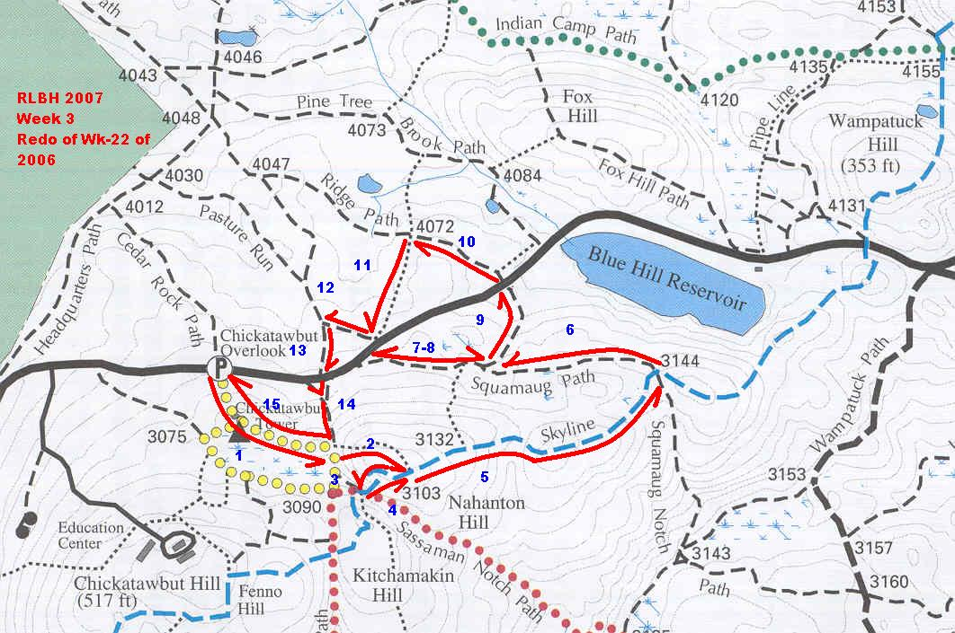
- Anyone with any medical conditions (asthma and use an inhaler, allergies and carry an Epipen, etc.) please inform me. )
- Non-AMC members are permitted (encouraged!) to attend. (Hopefully having fun with us will encourage them/you to join. ☺)
- If you wish to bring a friend, whom you know to have experience, the proper equipment, etc, just let me know a few days before the hike.
- There are rattlesnakes and copperheads within the Blue Hills. (They are rare, but they do exist) If you are concerned about this ask me now, not if we meet one on the trail ;-)

Any questions, call or email me.

Jim Plouffe, Co-leader
Jimplouffe@comcast.net
(508) 586-1394

